Name: Lastname, Firstname
Student access ID:
Project: JEdit
Change Number: [1,2,3,…]
Date: mm/dd/20012
Team Number:

Everything in italic should be changed as appropriate by you and should not be italic when submitted. Also remember code is not changed until the Actualization stage, so nowhere in this report should the words “I changed” or similar appear. No credit will be given if actualization is described.
(Title of the change request)

- Change Request:
In this section, describe the change that you were requested to do. Give any relevant background information or any essential details.

- Concept Location:
Explain the methodology that you have used to locate each concept that was part of your change request. Using Table 1 (expand if necessary), list all the files in the order that you have visited them (2nd column). Explain how you have found each file (3rd column). You can simply read the source code, but we encourage you to use the features provided by Eclipse shown in the class (right-click class and method names to find these exploration tools). You are also encouraged to use other tools if you wish, such as JRipples. In the fourth column, mention whether the class is related to the concept or not. Use one of the following terms (from the textbook):
- Use “Unchanged” if the class has no relation to the concept but you have visited it.
- Use “Propagating” if you read the source code of the class and it guided you to the location of the concept, but you will not change it.
- Use “Changed” if the class will be changed.
In the fifth column, write what you have learned about the class.

Table 1. The list of all the classes visited during concept location.
# | File name | Tool used | Located? | Comments

- Impact Analysis:
Using table 2 list the classes that you visited after you located the concept. On the first row, include the class where you have located the concept, i.e. the class that will be changed (2nd column). Explain how you have found each of the classes, i.e. which tools have you used (3rd column). Do you think that the class will be impacted by the change? (4th column). Write short comments explaining what have you learned about each class. What other tools you would like to have in Eclipse so that impact analysis would be faster?

Table 2. The list of all the classes visited during impact analysis.
# | Class name | Tool used | Impacted? | Comments

- Learning process: Include a partial UML class diagram. The class diagram must contain all the classes that you visited and all the relations (dependencies) between the classes that you understood. (see Figure 1). Mark the classes that were changed with red text as in the example.
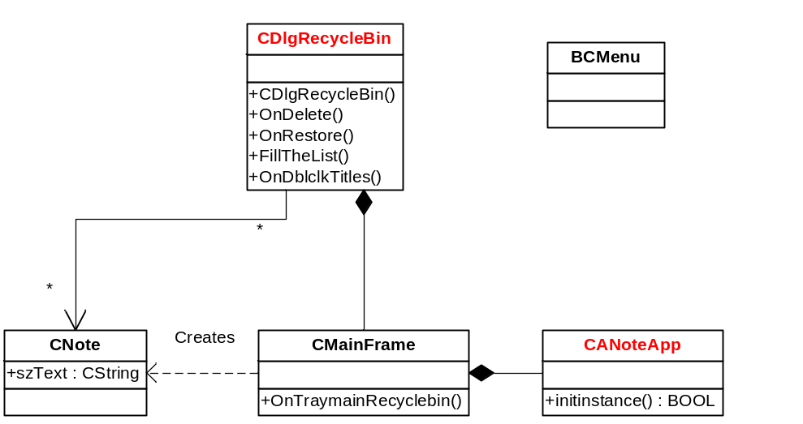
Figure 1 Example of the class diagram

